© 2021 Little Owls Resources

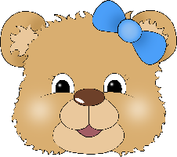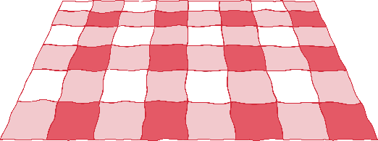

Draw the rest of Teddy!

© 2021 Little Owls Resources



Draw the rest of Teddy!

© 2021 Little Owls Resources



Draw the rest of Teddy!

© 2021 Little Owls Resources



Draw the rest of Teddy!

© 2021 Little Owls Resources



Draw the rest of Teddy!

© 2021 Little Owls Resources



Draw the rest of Teddy!

© 2021 Little Owls Resources



Draw the rest of Teddy!

© 2021 Little Owls Resources



Draw the rest of Teddy!

