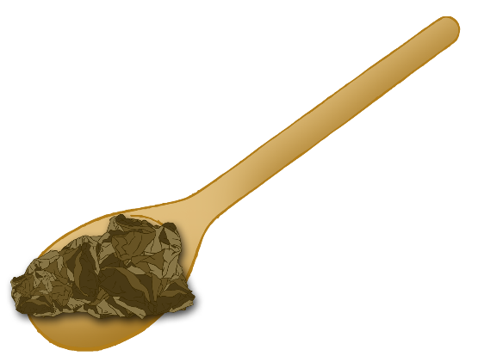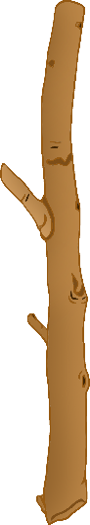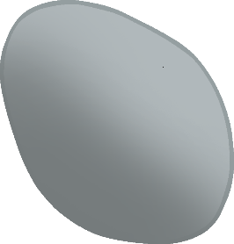

**How many?**

Sticks

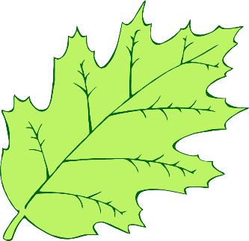

Stones

Spoons of Mud

Leaves

© 2021 Little Owls Resources



**How many?**

Sticks



Stones

Spoons of Mud

Leaves

© 2021 Little Owls Resources

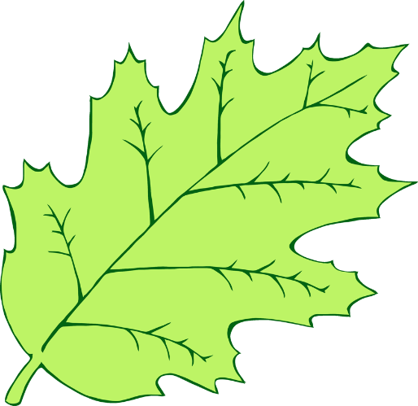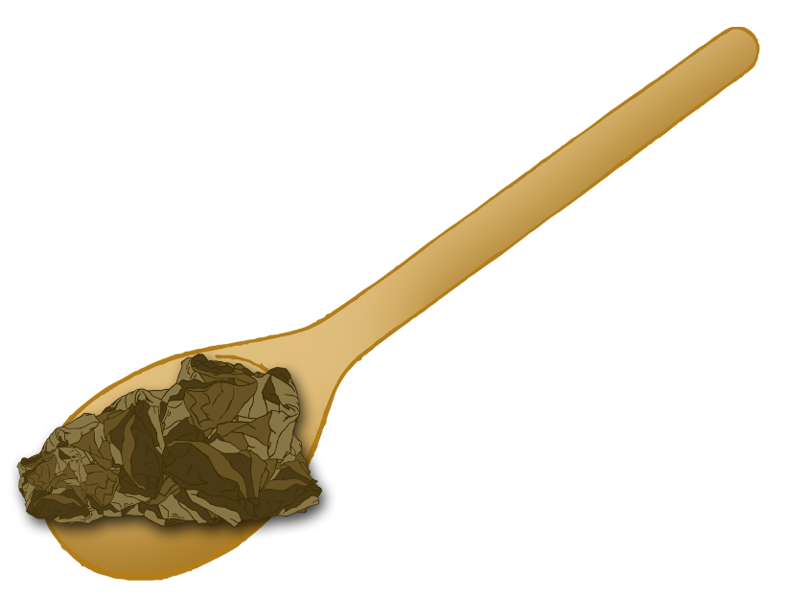

Leaves

Sticks

Spoons of Mud

Stones

© 2021 Little Owls Resources

**How many?**